Rajiv Gandhi University of Knowledge Technologies
Andhra Pradesh -Kadapa(D)

RK VALLEY ,YSR KADAPA (Dis) -516330

A Project Report
On
GATE PREPARATION WEBSITE

Submitted By :
NAME : V.ANJALI
ID NO : R180236
BRANCH : CSE



Under the Guidance of

MR. KETINENI VINOD KUMAR
(Assistant Professor)

Department Of Computer Science Engineering
This Project Report has been submitted in fulfilment of the
requirements for the Degree of Bachelor of Technology in Software . Engineering.

AUGUST -2023

Rajiv Gandhi University of Knowledge Technologies
IIIT, R. K. Valley, YSR Kadapa (Dis)-516330

CERTIFICATE

This is to certify that report entitled "GATE PREPARATION WEBSITE" Submitted by V.ANJALI(R180236) in partial fulfilment of the requirements of the award of Bachelor of technology in computer science engineering is a bona fide work carried by the under the supervision and guidance.

The report has been not submitted previously in part or full to this or any other university or institute for the award of any degree or diploma.

GUIDE HEAD OF THE DEPARTMENT
Mr. K. Vinod KUMAR Mr. N. Satyanandram
Assistant Professor HOD OF CSE

Submitted for the practical examination held on…………………..

Internal Examiner External Examiner

ACKNOWLEDGMENT

The satisfaction that accompanies the successful completion of any task would he
incomplete without the mention of the people who made it possible and who's constant guidance and encouragement crown all the efforts success.

We would like to express my sincere gratitude to Mr. K. Vinod Kumar, my project guide for valuable suggestions and keen interest throughout the progress of our project.

We are grateful to Mr. N. Satyanandram HOD CSE ,for providing excellent
computing facilities and congenial atmosphere for progressing our project.
At the outset, we would like to think Rajiv Gandhi University of Knowledge
Technologies (RGUKT), for providing all the necessary resources and support for the successful completion of my course work.

DECLARATION

Me V.ANJALI here by declare that the project report entitled "GATE PREPARATION WEBSITE " done under guidance of Mr. K. Vinod Kumar submitted in partial fulfillment for the degree of Bachelor of Technology in Computer Science and Engineering .during the academic session September 2022 April 2023 at RGUKT-RK Valley. I also declare that this project is a result of my own effort and has not been copied or imitated from any source. Citations from any websites are mentioned in the references. To the best of my knowledge, the results embodied in this dissertation work have not been submitted to any university or institute for the award of any degree or diploma.

Date: V.ANJALI(R180236)
Place :RK VALLEY

INDEX

S.NO | TITLE | PAGE NO
1 | ABSTRACT
 | ABSTRACT
 | ABSTACT
 | ABSTACT
 | ABSTACT
 | ABSTACT
 | ABSTACT
 | ABSTACT
 | ABSTACT
 | ABSTACT
 | ABSTACT
 | ABSTACT

ABSTRACT

GATE Preparation website is an online platform designed to provide effective exam preparation resources for students whoever preparing for the Graduate Aptitude Test In Engineering(GATE). The Gate preparation website aims
to make GATE preparation accessible to all students .

The website offers many features that include video lectures ,practice quizzes and mock tests as well as study materials such as notes ,books and solved papers.These resources are provided by experienced faculty members and subject experts.This website provides a personalized learning experiences for each student.

In addition to these features ,this website offers a community forum where students can interact with each other and discuss their doubts and queries with faculty members.this creates a supportive and collaborative learning environment that helps students stay motivated and engaged in their exam preparation.Overall Gate Preparation website is a comprehensive and effective online platform that provides all the resources and support the students to excel in the GATE exam.

SIGNATURE OF THE GUIDE

INTRODUCTION

GATE (Graduate Aptitude Test in Engineering) preparation website! We are thrilled to provide you with a one-stop platform designed to help you excel in your GATE examination and achieve your academic and career aspirations.

Key features of our GATE preparation website:
1. Expert Content: Our platform offers a comprehensive range of study materials, including detailed subject-wise notes, practice questions, mock tests, and previous years' question papers. These resources are curated by experienced faculty members and industry experts, ensuring the highest quality of content.
2 .Personalized Learning Paths: We understand that every student has unique strengths and areas for improvement. Our website offers personalized learning paths that adapt to your progress and provide targeted recommendations to help you focus on your weak areas.
3.Interactive Learning: Engage in interactive video lectures, live doubt-solving sessions, and discussion forums to foster a collaborative learning environment. Connect with fellow aspirants, share knowledge, and clarify doubts with the help of our dedicated community.
4.Mock Tests and Performance Analytics: Put your skills to the test with our realistic mock tests that simulate the actual GATE exam. Receive detailed performance analytics and insights to track your progress, identify areas that need more attention, and fine-tune your study strategy accordingly.
5.Timely Updates and Notifications: Stay informed about important exam dates, application deadlines, syllabus changes, and other relevant updates. We ensure that you are always in the loop and well-prepared for every aspect of the GATE examination.
6.Comprehensive Subject Coverage: From core engineering subjects to specialized topics, our website covers the entire GATE syllabus, ensuring you have a solid foundation in all areas.

PURPOSE
The purpose of a GATE (Graduate Aptitude Test in Engineering) preparation website is to assist aspiring engineers in their journey to successfully crack the GATE exam. GATE is a highly competitive and standardized examination that evaluates a candidate's understanding of various engineering subjects and is used for admissions to postgraduate programs (Masters and PhD) in prestigious institutes, as well as for recruitment in top-tier public and private sector organizations.

OVERALL DESCRIPTION

1.Comprehensive Study Material: The website provides a repository of well-organized and curated study materials, including subject-wise notes, practice questions, solved examples, and previous years' question papers. These resources ensure comprehensive coverage of the GATE syllabus and help candidates build a strong foundation in the relevant subjects.
2. Effective Learning Strategies: The website offers personalized learning paths and study plans based on a candidate's strengths and weaknesses. It guides candidates on how to approach their preparation, manage their time, and focus on key areas that require improvement.
3.Mock Tests and Practice: The website hosts mock tests that simulate the actual GATE exam environment. Regularly taking these tests helps candidates become familiar with the exam pattern, manage time effectively, and gauge their readiness for the real exam. Detailed performance analysis after each test helps candidates identify their strengths and areas needing improvement.
4.Performance Tracking: The website provides performance analytics and progress tracking tools. Candidates can monitor their progress, track improvements, and adjust their study strategy accordingly.
5.Convenient Access: With the website being accessible online, candidates can study and practice from the comfort of their homes or while on the move, using various devices like laptops, tablets, and smartphones.

EXISTING SYSTEM
Websites provided a wealth of study materials, including notes, practice questions, and previous years' papers, helping students cover the entire GATE syllabus.
Realistic mock tests with detailed solutions were available, enabling students to practice under exam-like conditions and gauge their progress.Detailed performance analysis after mock tests helped students identify strengths and weaknesses.Mobile-friendly platforms ensured learning on various devices.

DRAWBACKS OF EXISTING SYSTEM

1. Lack of Individual Attention: Despite personalized learning paths, some students might require more individualized attention that the platform couldn't provide.
2. Dependency on Technology: Technical issues or disruptions could affect the learning experience, leading to frustration.
3 .Quality Control: The quality of study material and faculty expertise varied across different platforms.
4 .Limited Hands-On Practice: Practical subjects might have limitations in offering hands-on practice through online platforms.
5 .Cost: Premium features or courses could be expensive, limiting access for some students.
6.Dynamic Syllabus Changes: GATE syllabus occasionally changes, and keeping the platform updated might be a challenge.
7.Authenticity of Resources: Ensuring that practice questions and mock tests are accurate representations of the GATE exam could be difficult.
8. Self-Discipline: Some students found it challenging to maintain consistent self-discipline without a structured classroom environment.
9.Isolation: While online platforms offered community engagement, some students missed the in-person interaction of traditional coaching centers.

PROPOSED SYSTEM
A conceptual proposed system for a GATE preparation website that aims to address the drawbacks of existing systems and enhance the overall learning experience. Please note that this is a hypothetical system and not a real implementation.
Here's a detailed overview
Offer in-depth analytics that track progress across various subjects and concepts.Generate visual reports and insights to help students identify trends and make informed study decisions.Create a realistic exam simulation center with timed mock tests and exam-like conditions.Provide instant feedback, score analysis, and comparisons to peers.
Extend the platform beyond GATE preparation to offer ongoing skill development and upskilling resources.
This proposed system envisions a comprehensive, technology-driven platform that combines AI, gamification, collaborative learning, and intelligent mentoring to offer a holistic and effective GATE preparation experience. It aims to overcome the limitations of traditional methods and existing online platforms by creating a personalized, engaging, and adaptable ecosystem for aspiring engineers. Remember that the feasibility and success of such a system would depend on rigorous research, development, user testing, and continuous improvement based on user feedback.

SYSTEM REQUIREMENTS
Software Requirements
- Html
- CSS
- Javascript
- PHP
- SQL server
Hardware Requirements
- Laptop

TOOLS AND TECHNOLOGIES USED

The various system tools that have been used in developing both front end, back end and other tools of the project are being discussed in this section.

FRONT END:
HTML, CSS, JAVASCRPIT ,BOOTSTRAP are utilized to implement the frontend.

1.HTML (Hyper Text Markup Language)
HTML is a syntax is used to format a text document on the webpages.the standard markup language used to structure and present content on the World Wide Web. It forms the foundation of web pages and provides a structured way to define the elements and layout of a webpage

2.CSS (Cascading Style Sheets)
CSS is a style sheet language is used for describing the look and formatting of a document written in a markup language.It allows you to control the layout, colors, fonts, and other visual aspects of a webpage, making it visually appealing and user-friendly. CSS works by defining rules that specify how different elements on a webpage should be displayed.

3.JAVASCRIPT
JS is a dynamic computer programming language. It is most commonly used as part of web browsers, whose implementations allow client side scripts to interact with the user, control the
browser, communicate asynchronously and alter the document content that is displayed.

BACKEND:
The backend is implemented using MYSQL and PHP which is used to design the databases.

4.MYSQL
MYSQL is the world’s second most widely used open source relational database management
system (RDBMS). The SQL phase stands for structured query language.

5.PHP
PHP is a server side scripting language designed for web development but also used as a general purpose programming language. PHP code is interpreted by web server with a PHP processor module, which generates the resulting webpage: PHP commands can be embedded directed into an HTML source document.

6.BOOTSTRAP
Bootstrap is a popular front-end framework for building responsive and visually appealing websites and web applications. It provides a collection of pre-designed HTML, CSS, and JavaScript components that make it easier to create consistent and professional-looking user interfaces. Bootstrap simplifies the process of designing and structuring web content, regardless of the user's device or screen size.

SOURCE CODE

GATE PREP.html
<!DOCTYPE html>
<html lang="en"><head>
<meta charset="UTF-8" />
<meta http-equiv="X-UA-Compatible" content="IE=edge" />
<meta name="viewport" content="width=device-width, initial-scale=1.0" />
<title>Gate Preparation Website</title>
<link rel="stylesheet" href="/home/apiiit-rkv/Desktop/MINI PROJECT/CSS FILES/style.css" />
<!-- Unicons -->
<link rel="stylesheet" href="https://unicons.iconscout.com/release/v4.0.0/css/line.css" />
</head>
<body>
<!-- Header -->
<header class="header">
<nav class="nav">
<a href="#" class="nav_logo">GATEPREP</a><div>
<ul class="nav_items">
<li class="nav_item">
<a href="#/home/apiiit-rkv/Desktop/Mini Project/project/login.html" class="nav_link" onclick="alert('First Login into the Website')">Home</a>
<a href="#" class="nav_link" onclick="alert('First Login into the Website')" >about</a>
<a href="#" class="nav_link"onclick="alert('First Login into the Website')">Faculties</a>
<a href="#" class="nav_link"onclick="alert('First Login into the Website')">Ref Books</a>
<a href="#" class="nav_link"onclick="alert('First Login into the Website')">Mock Tests</a>
<a href="#" class="nav_link"onclick="alert('First Login into the Website')">Websites</a>
<a href="#" class="nav_link"onclick="alert('First Login into the Website')">Branches</a>
<a href="#" class="nav_link"onclick="alert('First Login into the Website')">Model Papers</a>
</div>
<button class="button" id="form-open">Login</button>
</nav> </header>
<!-- Home -->
<section class="home">
<div class="form_container">
<i class="uil uil-times form_close"></i>
<!-- Login From -->
<div class="form login_form">
<li><a href="#Home"></a></li>
<form action="/home/apiiit-rkv/Desktop/MINI PROJECT/HTML FILES/home page.html" method="post">
<h2>Login</h2>
<div class="input_box">
<input type="email" placeholder="Enter your email" required />
<i class="uil uil-envelope-alt email"></i>
</div>
<div class="input_box">
<input type="password" placeholder="Enter your password" required />
<i class="uil uil-lock password"></i>
<i class="uil uil-eye-slash pw_hide"></i>
</div>
<div class="option_field">
<span class="checkbox">
<input type="checkbox" id="check" />
<label for="check">Remember me</label>
</span>
<a href="#" class="forgot_pw">Forgot password?</a>
</div>

<button class="button" <li><a href="Home"></a></li>>Login Now</button>
<div class="login_signup">Don't have an account? <a href="#" id="signup">Signup</a></div>
</form>
</div>
<!-- Signup From -->
<div class="form signup_form">
<form action="#">
<h2>Signup</h2>
<div class="input_box">
<input type="email" placeholder="Enter your email" required />
<i class="uil uil-envelope-alt email"></i>
</div>
<div class="input_box">
<input type="password" placeholder="Create password" required />
<i class="uil uil-lock password"></i>
<i class="uil uil-eye-slash pw_hide"></i>
</div>
<div class="input_box">
<input type="password" placeholder="Confirm password" required />
<i class="uil uil-lock password"></i>
<i class="uil uil-eye-slash pw_hide"></i>
</div>
<button class="button">Signup Now</button>
<div class="login_signup">Already have an account? <a href="#" id="login">Login</a></div>
</form>
</div>
</div>
</section>
<script src="/home/apiiit-rkv/Desktop/MINI PROJECT/JAVASCRIPT FILES/script.js"></script>
</body></html>

SCRIPT.JS
const formOpenBtn = document.querySelector("#form-open"),
home = document.querySelector(".home"),
formContainer = document.querySelector(".form_container"),
formCloseBtn = document.querySelector(".form_close"),
signupBtn = document.querySelector("#signup"),
loginBtn = document.querySelector("#login"),
pwShowHide = document.querySelectorAll(".pw_hide");
formOpenBtn.addEventListener("click", () => home.classList.add("show"));
formCloseBtn.addEventListener("click", () => home.classList.remove("show"));
pwShowHide.forEach((icon) => {
icon.addEventListener("click", () => {
let getPwInput = icon.parentElement.querySelector("input");
if (getPwInput.type === "password") {
getPwInput.type = "text";
icon.classList.replace("uil-eye-slash", "uil-eye");
} else {
getPwInput.type = "password";
icon.classList.replace("uil-eye", "uil-eye-slash");}
});});
signupBtn.addEventListener("click", (e) => {
e.preventDefault();
formContainer.classList.add("active");});
loginBtn.addEventListener("click", (e) => {
e.preventDefault();
formContainer.classList.remove("active");});

OUTPUT

1 .LOGIN PAGE

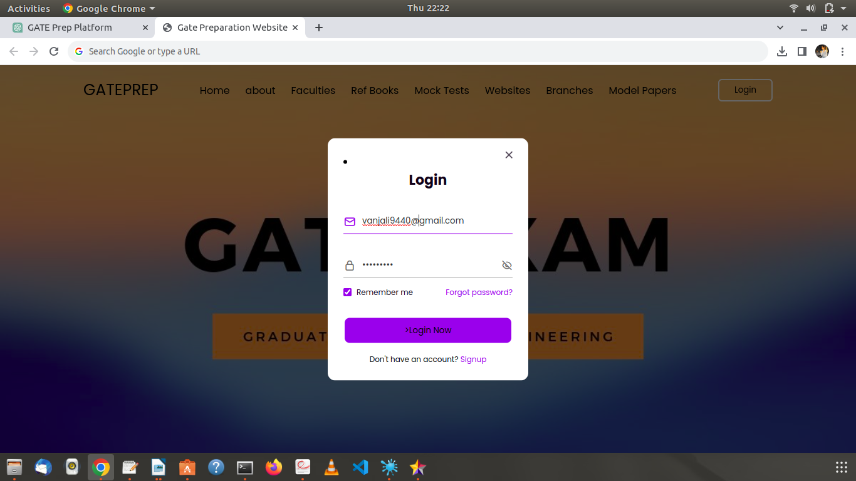

2 .HOME PAGE
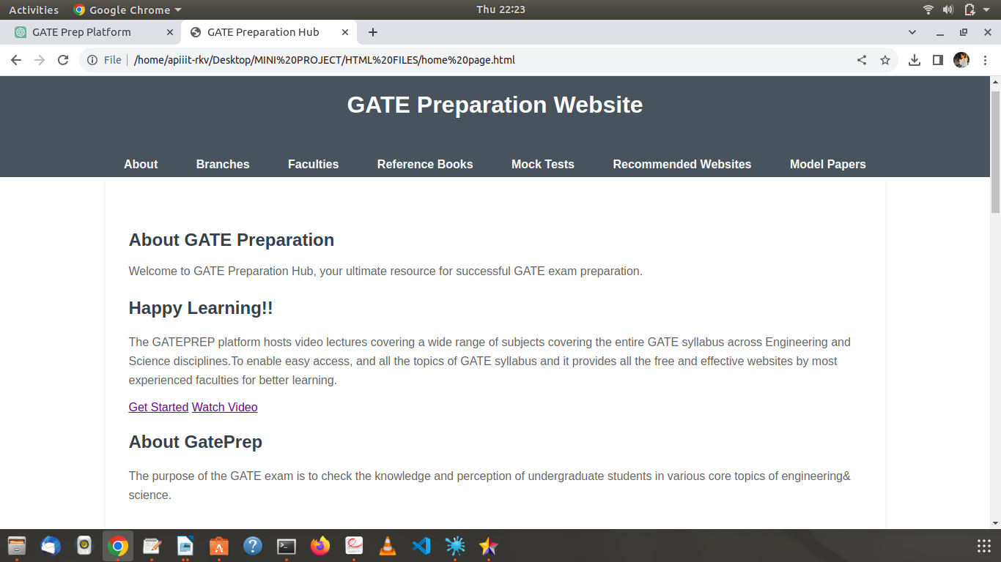
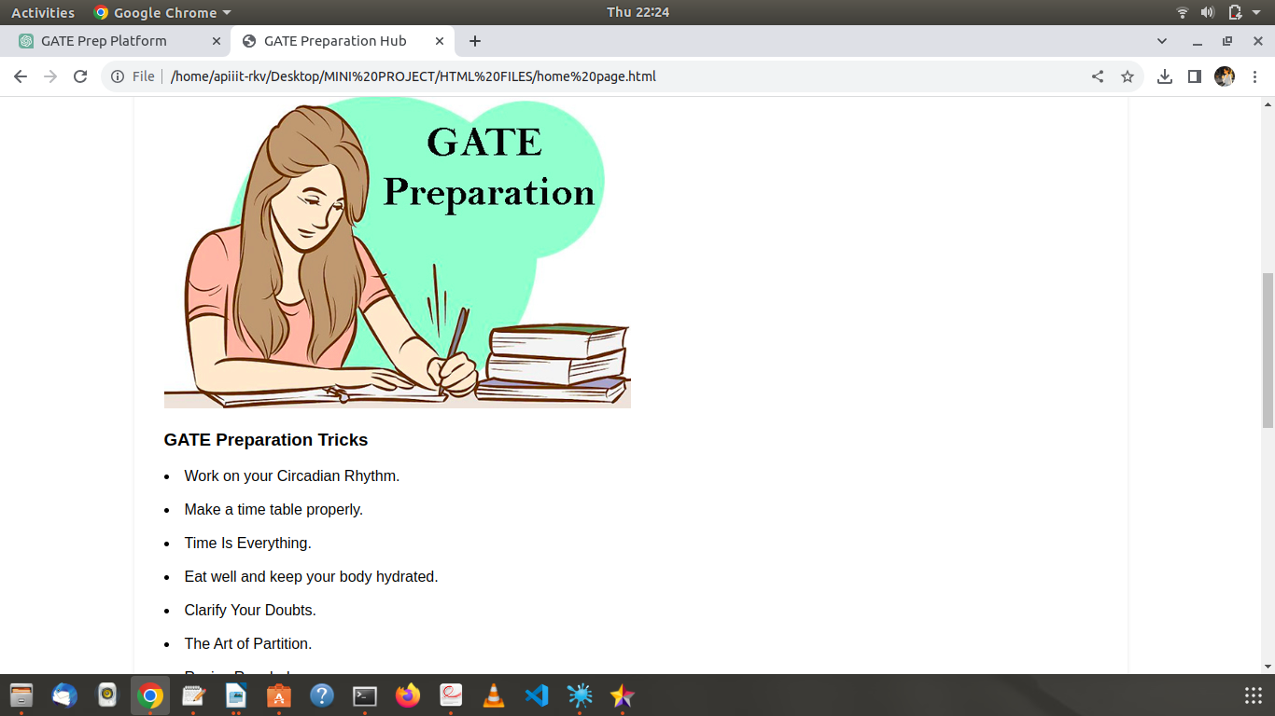

3 . BRANCHES PAGE
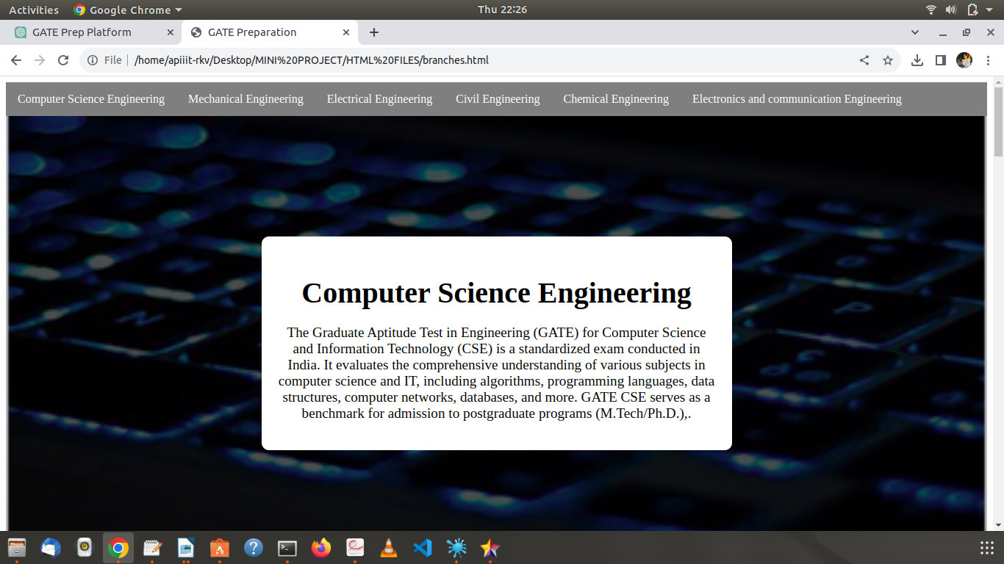
4 .FACULTIES PAGE

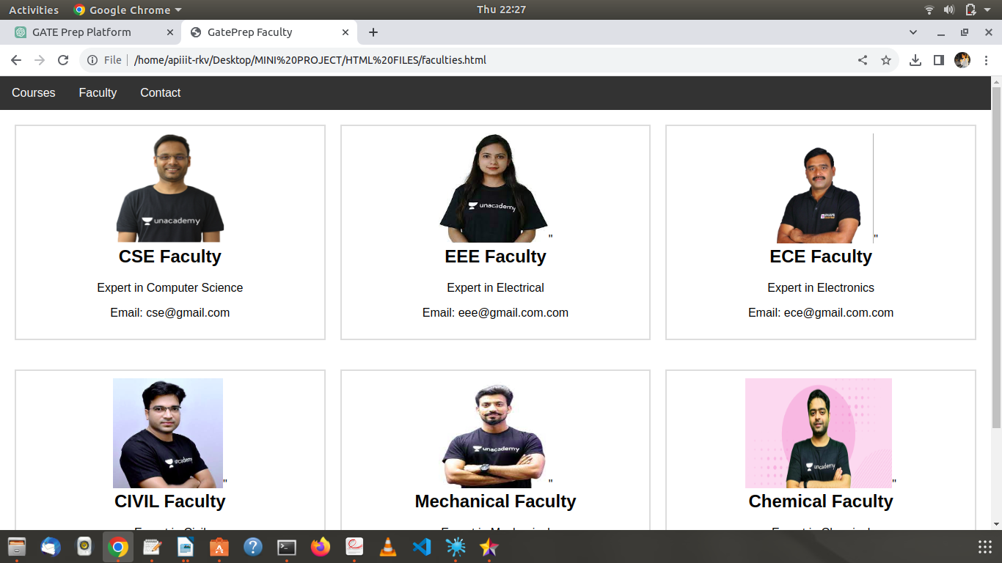

5.REFERENCE BOOKS PAGE
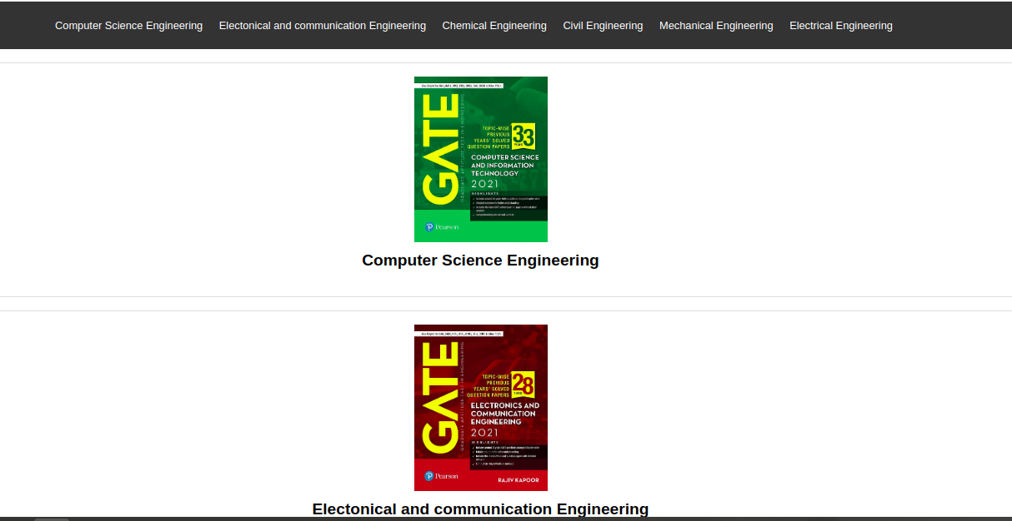
6 .MOCK TESTS PAGE
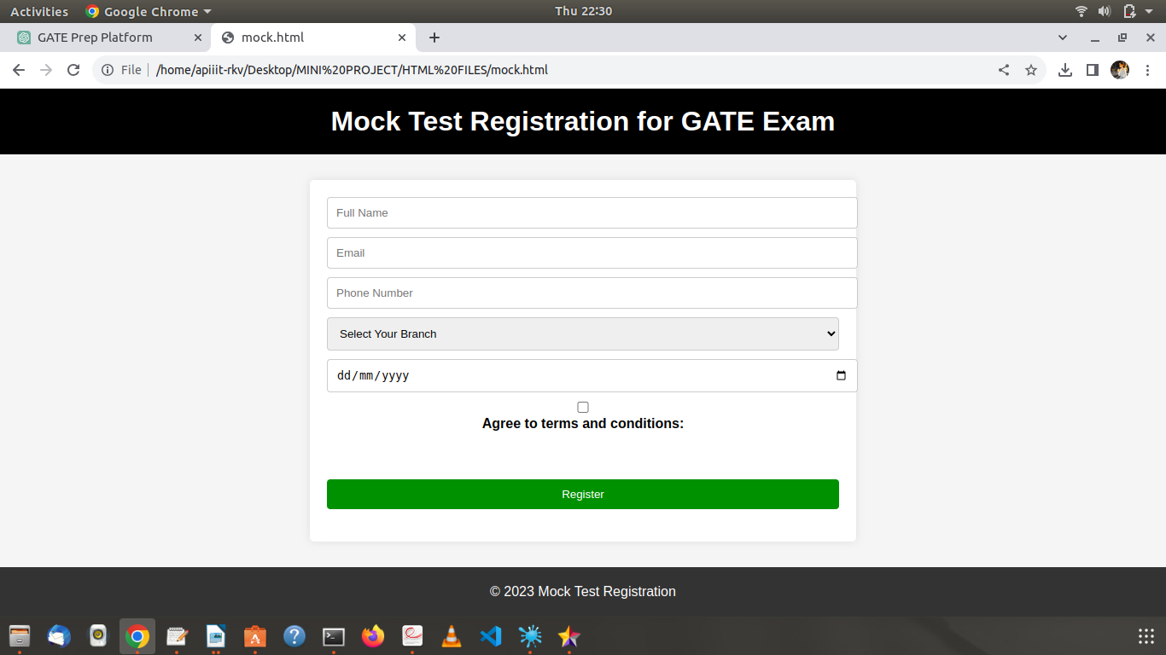

7. MOCK TESTS PAGE
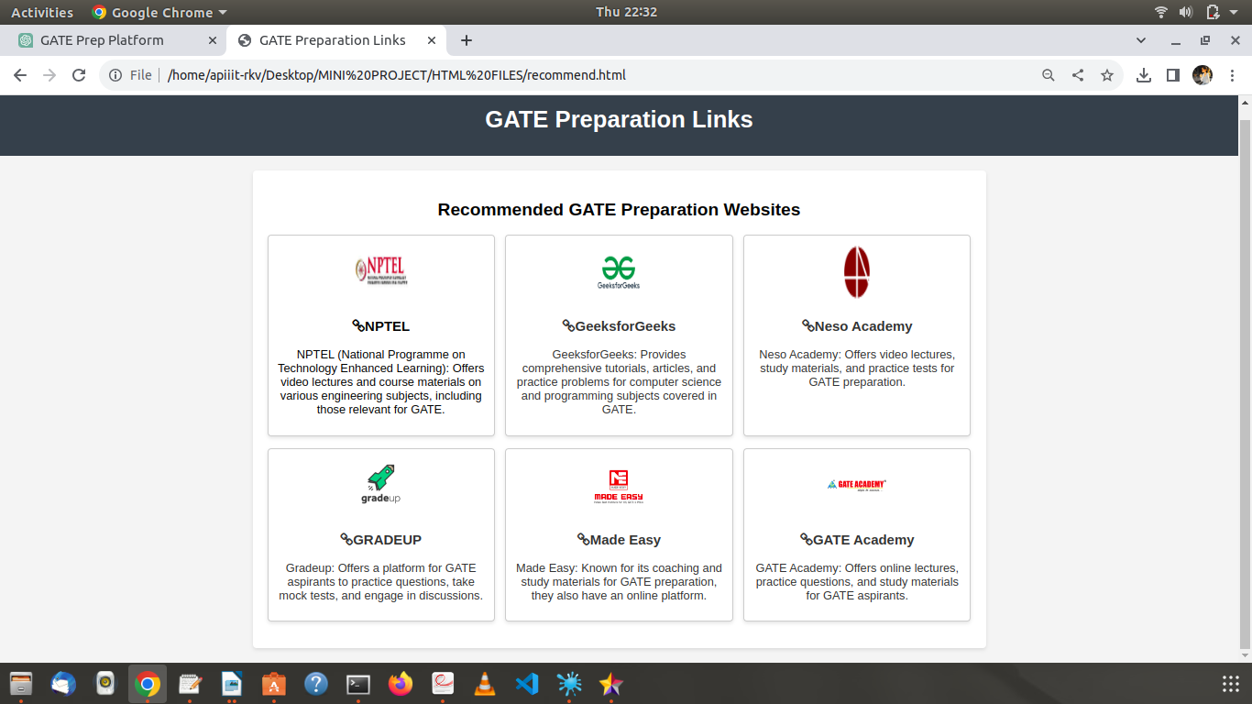
8.MODEL PAPERS
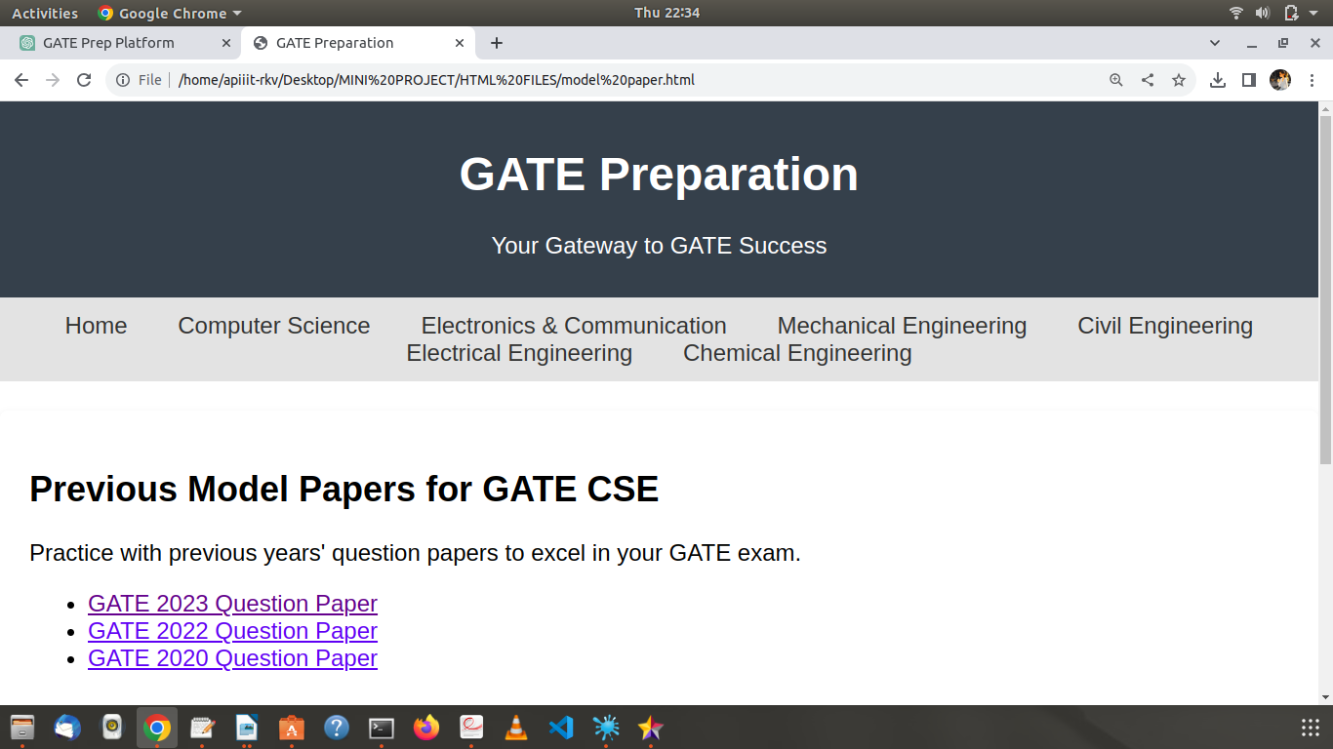

FUNCTIONAL Testing
Table1: LOGIN test case report:
S.NO | Action | Input | Expected Output | Actual Output | Final Output
1 | Enter details | Enter details | Displays home page | Displays home page | pass
2 | Enter details | Enter invalid password | Displays home page | error | fail
3 | Enter details | Enter invalid password,usern-ame | Displays home page | error | fail
4 | Enter details | Enter all valid details | Displays home page | Displays home page | pass
5 | Enter details | Enter all invalid details | Display home page | error | fail
6 | Enter details | Enter invalid phonenumber | Display home page | error | fail
Table2:login page test case report:
S.No | Action | Input | Actual result | Expected result | Result
1 | Enter details | Enter username and password | Display home page | Display home page | pass
2 | Enter details | Enter invalid username and valid password | Display home page | error | fail
3 | Enter details | Enter valid user name and invalid password | Display home page | error | fail
4 | Enter details | Enter invalid username and password | Dispaly home page | error | fail

Table3:MOCK TEST form test case report
S.no | Action | Input | Expected result | Actual result | Result
1 | Open form | Click form button | Showing form | Showing form | pass
2 | Enter details | Enter all details | Goes to next page | Goes to next page | pass
3 | Enter details | Enter invalid number | Goes to next page | error | fail
4 | Enter details | Enter invalid aadhar number | Goes go next page | error | fail
5 | Enter details | Enter incorrect confirm password | Goes to next page | error | fail

CONCLUSION
A well-designed GATE preparation website serves as a valuable and versatile platform for aspiring engineers to efficiently and effectively prepare for the Graduate Aptitude Test in Engineering (GATE) exam. Such a website brings together modern technology, interactive learning methods, and a supportive community to enhance the learning experience and improve the chances of success for GATE exam takers.
By offering a wide range of study materials, mock tests, video lectures, and personalized learning paths, the website empowers students to master complex engineering concepts, practice problem-solving skills, and gain a deep understanding of the exam syllabus.
The interactive components, including live doubt-solving sessions, discussion forums, and collaborative problem-solving sessions, foster a sense of community among students.

REFERENCES
This sample project report on "GATE PREPARATION WEBSITE" provides a structure that spans over 30 pages, incorporating key sections such as introduction, abstract, methodology, literature review, project implementation, results and findings, discussion, conclusion, recommendations, and references. You can expand each section further with relevant content, data, visuals, and case studies to create a comprehensive report tailored to your project's objectives and scope.
- Wikipedia
- Google
- youtube

